Academic Self Service

Student Information

Viewing student information on Qsis
- Go to Qsis (https://qsis.qub.ac.uk) and login using your QOL username/password.
- Click Self Service
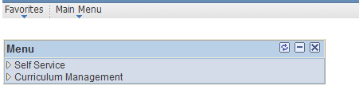
- Click on Advisor Center My Advisees. 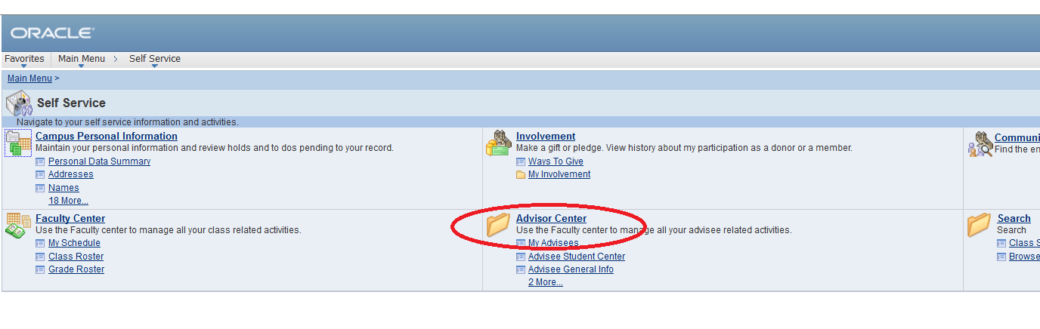
- This will list any students that are attached to you in Qsis in any capacity e.g. Advisee, Personal Tutee etc.
- To access a student’s Academic Record (this is a transcipt but with more information than what is printed on the official/unofficial transcript) select “View Academic Record. A separate window will open with a PDF file. You may have pop-up issues. You should allow pop-ups from this site – doing this the first time may return you to your starting point.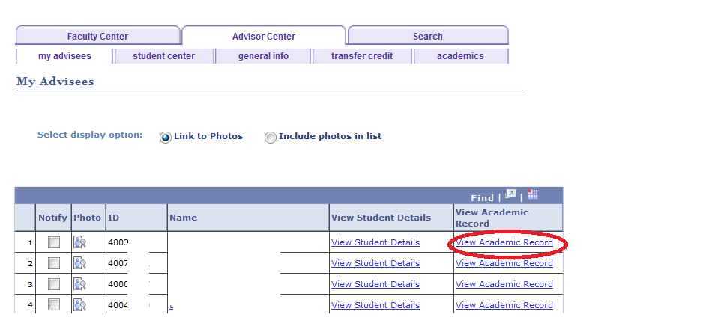
- To access personal student information click on View Student Details
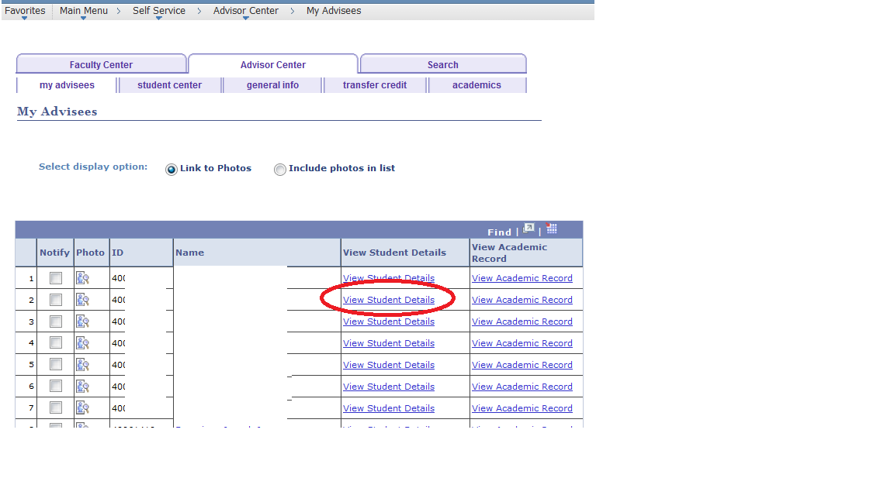
- From Student Centre you can view classes, addresses, phone numbers, emails, emergency contacts and view transcripts and Academic Records. Again you may have pop-up isssues.
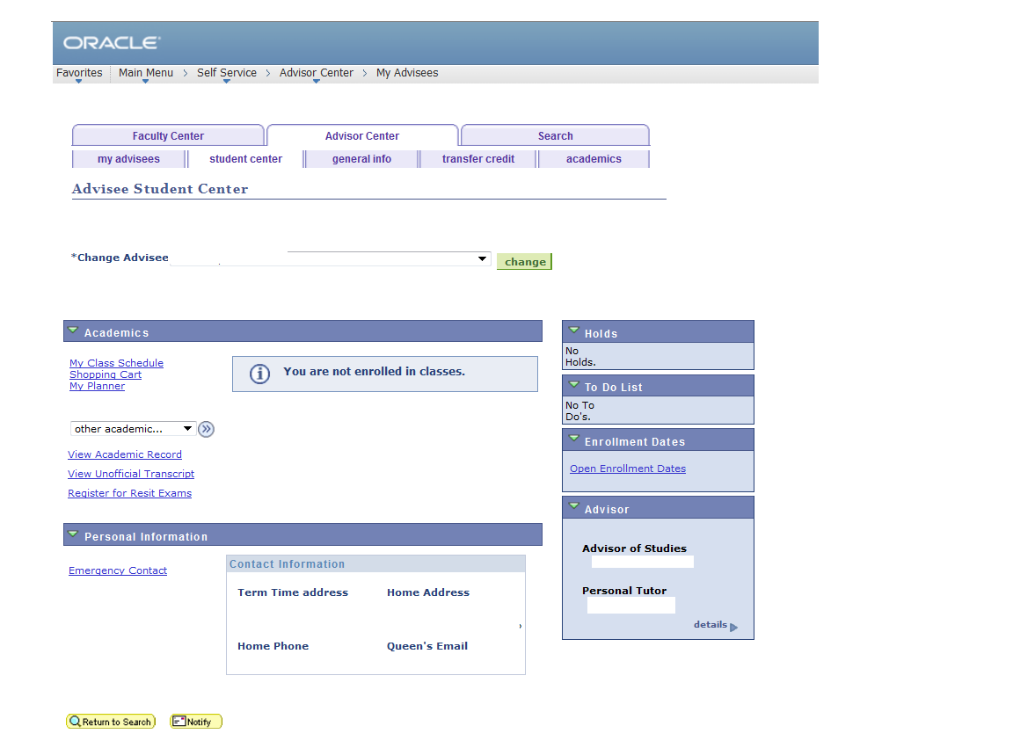

Viewing Data for other Students

It is also possible to view data for students not directly attached.
- Click on Advisor Center My Advisees.
- Scroll down to the bottom of the screen and select View Data for Other Students button.

- Enter a student number, or last and first name as search criteria. Once Student Centre opens, you can view transcripts from there.
